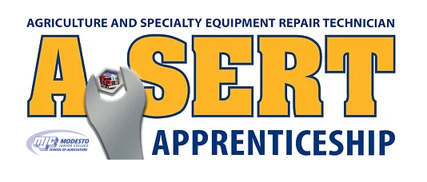A-SERT Apprenticeship  
NEWSLETTER

June 1, 2024

# Welcome To A-SERT!

## image_guitar.jpg

## Apprentice Spotlight

The A-SERT Apprenticeship is an industry-led training program dedicated to providing high-quality technicians through industry-driven instruction, structured on-the-job training, and focused recruitment activities. The A-SERT Program connects motivated workers with experts in the repair industry, provides comprehensive training to advance skills and qualifications on a national level, and builds a trusted workforce of repair professionals.

**Why Become an Apprentice?**

* Paid Job - Earn as you learn with a guaranteed wage increase as you develop your skills.
* Credentials - Receive an industry-recognized portable credential.
* Higher Wages - $77K Average starting Salary $300K Lifetime Earning Advantage.
* Education - Take college classes that count towards degrees and certificates. Gain workplace-relevant skills in the field of your choice through on-the-job learning.
* Post Secondary Certificate - All A-SERT apprentices will receive a college certificate at the completion of classes.
* Mentorship - Connect with mentor(s) in your chosen industry who can help you advance your career.

**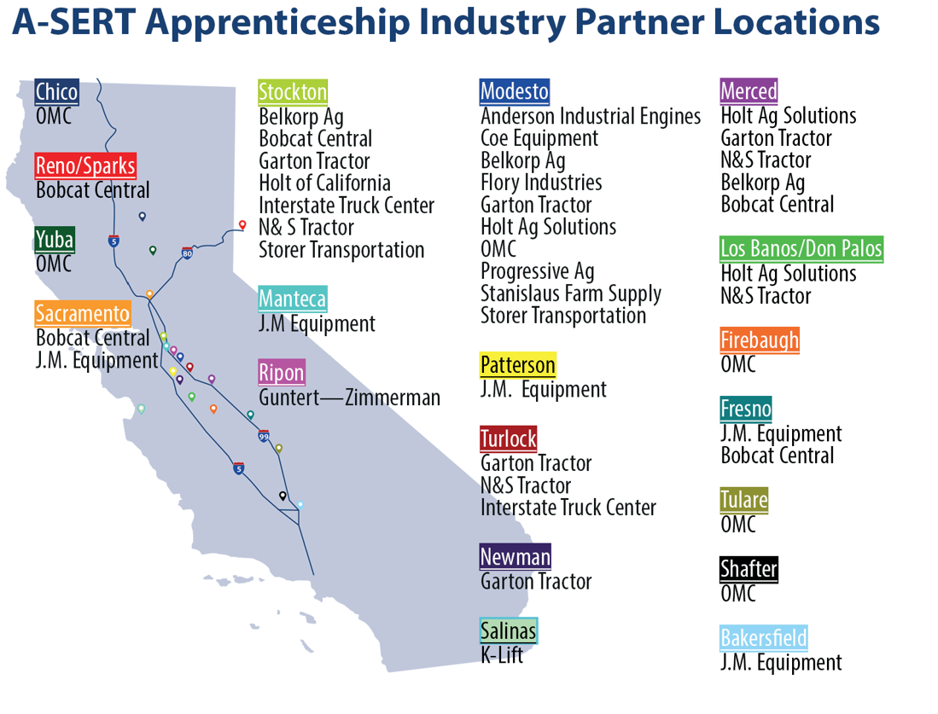What Industries Does A-SERT Support?**

The A-SERT Apprenticeship supports many industries; including those below. Any industry in need of highly skilled repair technicians will benefit from an A-SERT Apprentice.

* Agriculture
* Heavy Construction
* Forestry
* Trucking
* Rental
* Stationary Equipment
* Automotive Diesels
* Fleet Management
* Fleets

horizontal line

## 

## Employer Spotlight

At Garton Tractor, you’ll be satisfied by finding the quality products and people you’ve been looking for. We’re a family owned and operated business, four generations strong and we pride ourselves on our consistently excellent personnel. We hold ourselves to the highest of standards and are dedicated to continual improvement in everything we do.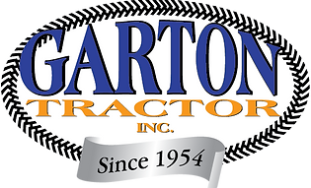

Our mission is, “To consistently provide our customers with an experience that exceeds their needs in Sales, Service, Parts, and Rentals with Quality People, Products, and Facilities.” We appreciate your business!

The values shared at Garton Tractor, Inc. are honesty, integrity, and treating others (customers and co-workers) with respect. We are proud of the people we have in our organization and grateful for our customers. Here at Garton Tractor, Inc., we have positive attitudes and strong work ethics to ultimately help you, the customer, in the best and most efficient way possible.

The agricultural industry is a diverse and exciting part of our nation. The San Joaquin Valley is the richest agricultural land in the world. A large part of this prosperity in farming depends on quality agricultural machinery and services. Being in business since 1954, Garton Tractor, Inc. has established that a customer:​

* Is the most important person at our Company.
* Is a human being with feelings much like our own.
* Deserves our most courteous and attentive treatment.
* Does not interrupt our work; they are the purpose of it.
* Brings us their needs, it is our job to fulfill them.
* Is an integral part of our Company; not an outsider.
* Does not depend on us; we depend on them.
* IS OUR BUSINESS!

The A-SERT Apprenticeship is an industry-led training program dedicated to providing high-quality technicians through industry-driven instruction, structured on-the-job training, and focused recruitment activities.

**How Can An Apprentice Benefit You?**

If you are a business that needs help in building a skilled workforce, then this may be one method that you can use to train current employees and attract new ones. If you have trouble finding employees, have high turnover, or are having difficulty in training your staff with relevant skills, then most likely the A-SERT program is for you.

* Skilled Workforce - Get help recruiting highly skilled employees.
* Improve Productivity - Improve profitability and positive impact to your bottom line.
* Reduced Turnover/Worker Retention - 91% of apprentices continue employment after completing an apprenticeship\*.
* Customizable Training - Have a voice in the classes and skills apprentices are required to learn.

horizontal line

## President’s Report

With the kick-off of our first year the team at A-SERT has been very busy. With the program registering its first apprentice and employer many new policies and procedures were created. The Board of Directors developed procedures for tracking apprentice hours, work processes, classroom instruction, etc. The Board also developed our very own website (A-SERT.net), attended many recruitment activities and is in the process of developing a newsletter. The Board President and the Executive Director put in countless hours in developing new employers to accept apprentices. This has been a time-consuming and often frustrating process. Though many of our contacts understand and agree with the need for such a program to promote and develop incoming talent into the repair industry, unfortunately convincing the decision makers and/or HR departments has been quite the challenge. The good news is that we are making progress and hope to expand the number of employers with apprentices this coming year. As always, we welcome any interest, questions or concerns regarding our program. We can be reached at our website (A-SERt.net) or by email at a-sert@outlook.com.

## A-SERT Treasurer's Report

Our inaugural year for the apprenticeship was a solid one financially. With five affiliate partners and one apprentice the program was able to start attaining our goals and responsibilities. The vast majority of the apprentice fees went to supporting the apprentice. The program paid for the tracking software “Workhands”, educational costs and job-related expenses including uniform patches and a basic tool set. With the influx of funds from affiliate fees the program was able to develop and purchase recruitment materials including; a website (A-SERT.net), business cards, printed materials, and a backdrop for recruitment booths. The president and executive directors also attended many recruitment activities at area high schools, career fairs, the California Farm Bureau state industry fair and the California Ag Teachers Associations Summer Conference industry fair. We are quickly entering our next round affiliate campaign, the continuing of our current apprentice and hopefully some incoming apprentices. The board of directors has been quite fiscally responsible, and the program is entering this second year with a strong financial base and hopefully with an influx of new affiliate partners and apprentices the program can expand our outreach and recruitment even more.

## 

## 

## We would like to thank our Affiliate Partners

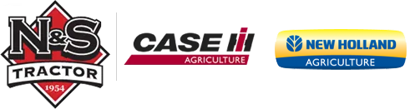 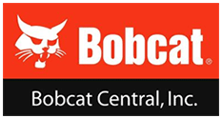

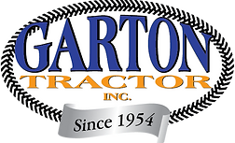 

| [**READ MORE ON OUR WEBSITE**](https://www.a-sert.net/) |
| --- |

horizontal line



A-SERT Apprenticeship

435 College Ave. Modesto, CA 95350