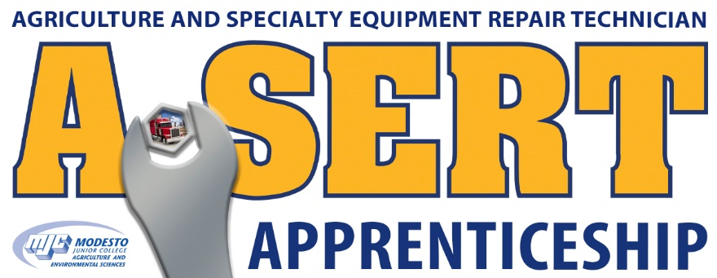

**Benefits of Affiliate fees**

Your company name / Logo included in all advertising, promotional and recruitment materials

Booth Displays

State FFA Convention

California Ag Teachers Association State Conference

Flyers

Tri-Folds

Posters

Recruitment at the following (at minimum)

7 Area high schools

Modesto JC Career Expo

MJC – Employer/Apprentice Pre-View

Participation in apprentice selection process

Access to the A-SERT Committee and input in the organization and apprenticeship program